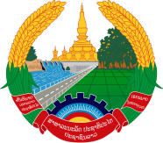

Statement by Mr. Sitsangkhom Sisaketh, Deputy Permanent Representative of the Lao PDR
At the 33rd Session of UPR Working Group
Geneva, 6 - 17 May 2019

Review of Bhutan: 8 May 2019

Mr. President,
Laos warmly welcomes the distinguished delegation of Bhutan to the 33rd Session of UPR Working Group and thanks for its comprehensive report on human rights development.

Laos sincerely commends the Government of Bhutan for the progress made in its efforts to promote and protect human rights in the country through the implementation of recommendations received in its previous cycle of UPR, including development of its national education policy and the Bhutan education blueprint.

In this connection, Laos wishes to recommend as follows:

- First, continue to improve the quality and access to education for all children especially children from rural communities; and
- Second, continue its efforts to implement the national policies and programmes aimed at further promoting gender equality as well as the rights of women and children.

We wish Bhutan every success in its UPR.

I thank you, Mr. President.

