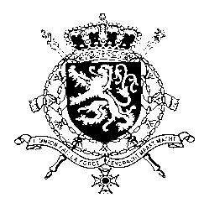
Représentation permanente de la Belgique auprès des Nations Unies et auprès des institutions spécialisées à Genève

WG UPR – Brunei
Belgian intervention
10th May 2019

Mr. President,

Belgium welcomes the delegation of Brunei and wishes it every success in the exercise of its third Universal Periodic Review. Belgium welcomes the recent announcement by the government of Brunei Darussalam to ratify the UN Convention Against Torture. Belgium is convinced that further progress can be achieved to increase the protection of human rights in line with the core international human rights treaties.

Therefore, we would like to formulate the following recommendations:

R1. Maintain the moratorium on executions with a view to abolishing the death penalty and revoke the Shariah penal code which foresees in the death penalty

R2. Decriminalize same-sex sexual conduct between consenting adults.

R3. Ratify the International Covenant on Civil and Political Rights, the International Covenant on Economic, Social and Cultural Rights, the Convention against Torture and Other Cruel Inhuman or Degrading Treatment or Punishment, the International Convention for the Protection of All Persons from Enforced Disappearance and the International Convention on the Elimination of All Forms of Racial Discrimination.

Thank you, Mr. President.

