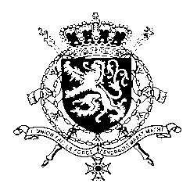
Représentation permanente de la Belgique auprès des Nations Unies et auprès des institutions spécialisées à Genève

WG UPR – Albania
Belgian intervention
6 May 2019

Mr. President,

Belgium welcomes the delegation of Albania and commends Albania for the progress made since the previous UPR, including through the adaptation of the Law on domestic Violence and the Law on the Rights and Protection of the Child. Belgium also welcomes the efforts undertaken to implement reforms in the field of public administration and public financial management. Notwithstanding this progress,, Belgium believes there is still room for improvement, in particular with regard to the fight against corruption and women’s and children’s rights.

Therefore, we recommend the government of Albania to:

R1. Ensure effective implementation of the recommendations of the Council of Europe Group of Experts on Action against Violence against Women and Domestic Violence.

R2. Take effective measures to fight child poverty, child slavery, forced labour and sexual exploitation of children.

R3. Make effective use, as soon as they will be established, of the new specialized anti-corruption institutions such as the Special Anti-Corruption and Organized Crime Structure and the National Bureau of Investigation to combat corruption and to ensure effective conviction of high profile cases.

Thank you, Mr. President.

