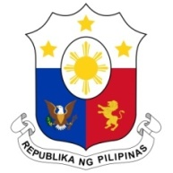
PHILIPPINES

33rd Working Group Session on the Universal Periodic Review
UPR OF QATAR
Salle XX, Palais des Nations
15 May 2019

Speaking Time: 1 min. 5 sec.
Speaking Order: 40 of 109

Thank you, Mister Vice-President.

The Philippines warmly welcomes the delegation of Qatar to this session.
My delegation is pleased to note Qatar’s accession to the ICCPR, ICESR, and the Marrakesh Treaty, among others.
We laud Qatar’s enactment of a number of legislations relating to the promotion and protection of the rights of migrant workers as well as domestic workers. We welcome the government’s efforts to uphold women’s political participation and leadership.
In a constructive spirit, the Philippines recommends the following:
- Further strengthen coordination efforts for the effective implementation of its National Plan to Combat Human Trafficking, including programs for care and protection of victims;

- Continue providing access to remedies for victims of domestic violence, including migrant workers; and

- Consider acceding to the International Convention on the Rights of All Migrant Workers and Members of their Families (ICRMW).

We wish Qatar every success in this UPR session.

Thank you, Mister Vice-President. END

