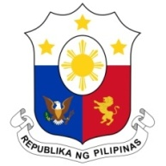
PHILIPPINES

33rd Working Group Session on the Universal Periodic Review
UPR OF ETHIOPIA
Salle XX, Palais des Nations
14 May 2019

Speaking Time: 55 sec.
Speaking Order: 20 of 135

Thank you, Madam Vice-President.

The Philippines welcomes the delegation of Ethiopia to this session.
My delegation is pleased to note the government’s efforts to mainstream human rights through education and training programs.
We welcome Ethiopia’s enactment of a law on human trafficking and smuggling of migrants, as well as its efforts to address their root causes.
In a constructive spirit, the Philippines recommends the following:
- Further strengthen concerted efforts toward the effective implementation of anti-trafficking in persons law;

- Continue enhancing programs that promote the economic and social empowerment of women; and

- Consider the ratification of the International Convention on the Rights of All Migrant Workers and Members of their Families (ICRMW).

We wish Ethiopia every success in this UPR session.

Thank you, Madam Vice-President. END

