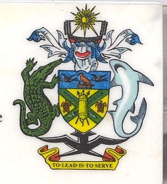
Solomon Islands Statement on Vanuatu’s Universal Periodic Review
32nd Session of UPR Working Group, Geneva
24 Thursday January 2019

Check Against Delivery

Mr. President,

Solomon Islands warmly welcome the delegation of Vanuatu led by Honourable Don Ken, Minister of Justice and Community Services, for its third UPR.
Solomon Islands commend Vanuatu for the marked progress it made since the last review in addressing its human rights obligations, particularly, amongst others, the significant legislative reforms to bring their domestic legislation in-step with International Law through the enactment of the Right to Information Act No 13 of 2016, Education Act No. 9 of 2014, Penal Code Amendment of 2016 and Water Supply Act No 31 of 2016.
Vanuatu has established a clear vision that guide its development goals through its Strategic Plan 2016-2020, which further detailed in the country’s corporate plans as relates to human rights, poverty reduction, education, social protection, and health improvement to meet the MDG targets.
To address the Climate Change related challenges, Vanuatu have established the Climate Change and Disaster Induced Displacement plan through numerous different adaptation methodologies.
Mr President, Vanuatu, like Solomon Islands, values their cultural and religious practices, which are the integral part of their society cohesiveness. They need to be respected.
In order for Vanuatu to fully achieve its development objectives and address its human rights obligations, it will need the support from the international community. Solomon Islands therefore, call on members to support Vanuatu in this effort.

Finally, we wish Vanuatu all the success during your review process.

Thank you Mr President.

