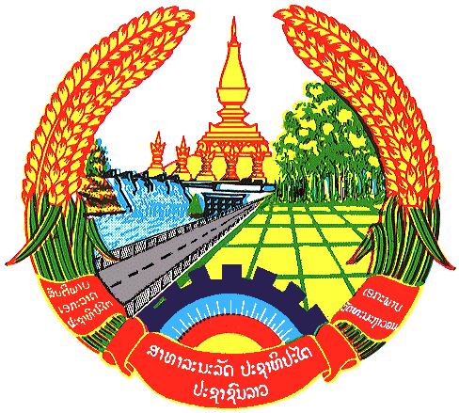

Statement by the delegation of the Lao PDR
At the 32th Session of UPR Working Group
Geneva, Switzerland

Review of Afghanistan: 21 January 2019

Mr. President,
The Lao delegation would like to welcome the delegation of Afghanistan and congratulate for its UPR report presented to the council.

We welcome the progress of Afghanistan’s efforts and steps taken to promote and protect human rights by formulating national committees and implementing national programs, including poverty reduction strategy.

Taking this opportunity, we would like to recommend Afghanistan to:

- Continue its efforts to further enhance gender equality and women’s empowerment in line with the SDGs; and
- Continue to provide programs to help the poor and other vulnerable groups, including in rural society to improve their skills and have better access to economic opportunities as well as basic services.

We wish Afghanistan a very success in its third cycle of UPR.

I thank you, Mr. President.

