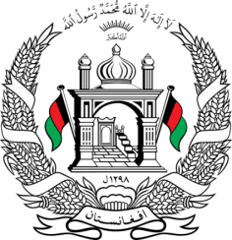
Permanent Mission of Islamic Republic of Afghanistan
32th Session of UPR Working Group
Statement at the 3th UPR of Yemen
(January 23, 2019)
Thank you, Mr. President!
Afghanistan welcomes the distinguished delegation of Yemen and thanks them for their engagement with the UPR process.
We appreciate the efforts taken by Yemen to rebuild and expand schools and educational facilities including introduction of programs for children with special needs and children from poor families. Furthermore, we commend Yemen for adopting a Decree that is set out to establish an Economic Committee authorized to provide necessary support to the most vulnerable groups in these challenging times.
With the spirit of constructive dialogue, Afghanistan recommend the Yemeni government:
- To strengthen and applies quality standards to their national strategies on education and takes necessary measures towards increasing access to education for all;
- To strengthen its efforts to alleviate poverty and malnutrition.
We wish the distinguished delegation of Yemen every success in the UPR process.
Thank you, Mr. President!

