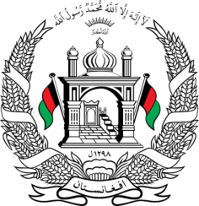
Permanent Mission of Islamic Republic of Afghanistan
32th Session of UPR Working Group
Statement at the 3th UPR of New Zealand
(January 21, 2019)
Thank you, Mr. President!
Afghanistan welcomes the distinguished delegation of New Zealand and thanks them for their engagement with the UPR process.
We congratulate the government of New Zealand for the human rights achievements they have made since the last UPR. We commend the government of New Zealand for the steps taken to increase the participation of women in senior level leadership in the public service and on the state sector boards and committees.
In the spirit of constructive dialogue, Afghanistan would like to make the following recommendations:
- To continue efforts for combating violence against women and increasing women's representation in leadership roles in the public sector
- Ensure the human rights of asylum seekers and consider ratifying the International Convention on the Protection of the Rights of All Migrant Workers and Members of Their Families.
We wish the distinguished delegation of the New Zealand every success in the UPR process.
Thank you, Mr. President!

