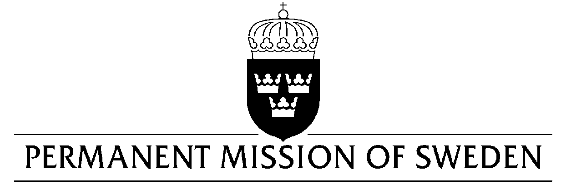
UN Human Rights Council

UPR 32nd session

Statement by Sweden in the interactive dialogue on Cambodia

Delivered by H.E. Ambassador Veronika Bard
Geneva, 30 January 2019 (speaking time 1.30 min, speaker no. 54)

Mr. President,
Sweden welcomes Cambodia’s participation in the UPR process and acknowledges steps towards a strengthening of LGBTI persons’ full enjoyment of human rights. However, Sweden still remains deeply concerned by the negative developments in Cambodia, not least with regard to political rights, including participation in political processes and freedom of expression and association, peaceful assembly and freedom of opinion. The use of the judiciary to restrict human rights also affect a range of other human rights and have contributed to a climate of fear, intimidation and self-censorship, including on the Internet.

Sweden would therefore like to make the following recommendations:

- To revise recent enactments and revisions of legislation that violate the rights to freedom of expression and association, including the vague and broad grounds for preventing publication on the Internet in the Proclamation on Publication Controls of Websites and social media.

- To ensure that the trade union rights of workers are guaranteed in line with ILO Convention #87 and that unions may register unhindered and represent their members.

- To introduce new legislation that guarantees equality and explicitly prohibits discrimination of LGBTI persons.

Sweden wishes Cambodia all success in the current review.

I thank you Mr. President.

