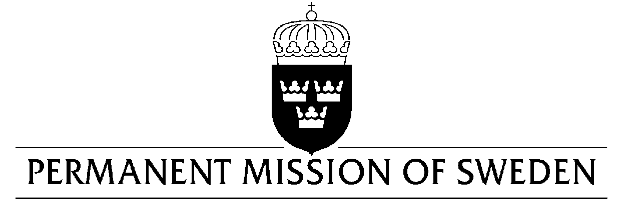
UN Human Rights Council

UPR 32nd session

Statement by Sweden in the interactive dialogue on Eritrea

Delivered by Ambassador Veronika Bard
Geneva, 28 January 2019 (speaking time 1.15 min, speaker no. 88)

Mr. President,

Sweden welcomes the State of Eritrea’s participation in the UPR process and acknowledges advancements of the human rights situation related to women’s rights and the rights of persons with disabilities and the human rights dialogue that we are conducting. However, Sweden remains seriously concerned over a number of human rights issues. Sweden calls on urgent reforms regarding the rule of law, freedom of expression and cooperation with the wider UN human rights system, including the HRC’s special procedures, and would therefore like to make the following recommendations:

- To urgently establish and implement a Constitution, guaranteeing universally recognized human rights for all Eritrean citizens.

- To release or bring before a court all persons detained without a charge and respect international standards in the treatment of detainees.

- To take concrete measures to ensure full respect for the rights to freedom of expression and opinion as well as freedom of religion or belief, including as it pertains to the press and other media.

Sweden wishes Eritrea all success in the current review.

I thank you Mr. President.

