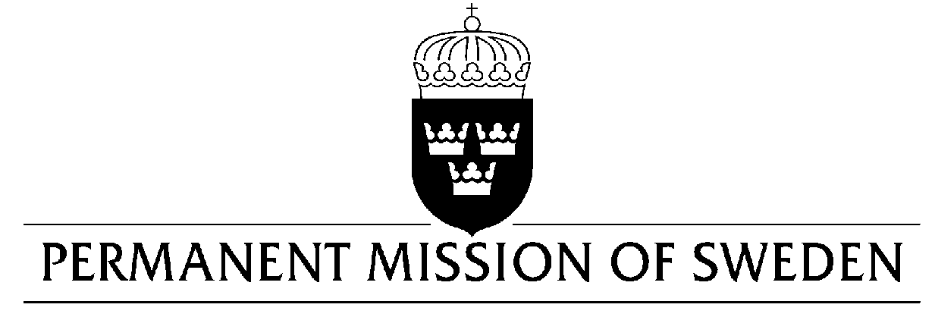
UN Human Rights Council

UPR 32nd session

Statement by Sweden in the interactive dialogue on the former Yugoslav Republic of Macedonia

Geneva, 24 January 2019 (speaking time 1.55 min, speaker no. 59)

Mr. President,
Sweden welcomes that the former Yugoslav Republic of Macedonia have formulated targeted policies and national strategies, especially regarding gender-based violence, the development of the Penitentiary System as well as for inclusion of Roma. However, the respect for human rights and the rule of law could be strengthened and the practical implementation improved. Therefore, Sweden would like to make the following recommendations:

- To amend the criminal code to criminalize marital rape.

- To remove the requirement of penetration in the definition of rape.

- To continue with reforms of the penitentiary system, particularly to strengthen the mechanisms for oversight, in line with recommendations by CPT with the view to provide much needed check-ups of the treatment of convicts and detainees.

- To direct further efforts towards the inclusion of Roma in primary as well as secondary education, including earmarked budget in local and national budgets towards this end.

Sweden wishes the former Yugoslav Republic of Macedonia all success in the current review.

I thank you Mr. President.

