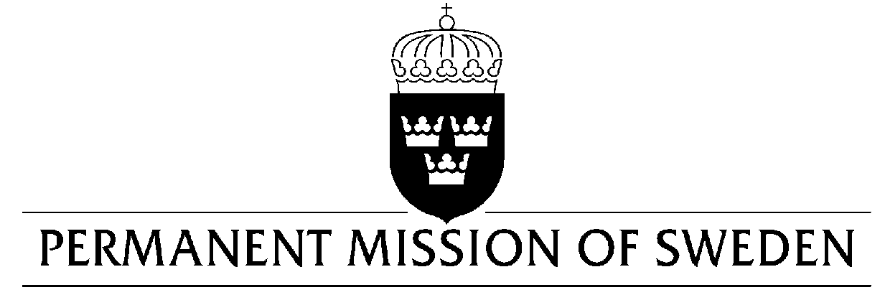
UN Human Rights Council

UPR 32nd session

Statement by Sweden in the interactive dialogue on Uruguay

Geneva, 23 January 2019 (speaking time 1.20 min, speaker no. 58)

Mr. President,

Sweden acknowledges the Uruguayan Government’s commitment to strengthen the respect for human rights both nationally and internationally. Sweden welcomes the adoption of new legislation to address violence against women as well as the adoption of a reformed Code of Criminal Procedure to improve conditions in prisons and the treatment of prisoners. However, in light of continued high rates of violence against women, as well as high levels of recidivism and overcrowded prisons, we would like to underline the importance of effective implementation of the abovementioned laws and therefore make the following recommendations:

- To ensure that sufficient resources are allocated to the judicial system in order to implement the national legislation to combat violence against women, and to duly process and investigate suspected cases of violence.

- To take active measures in order to ensure that full and equal participation of women in politics increases, in accordance with the law regulating party lists for legislative elections.

- To ensure that sufficient resources are in place to fully implement the reformed Code of Criminal Procedure in order to further reduce overcrowding in prisons, rehabilitate prisoners to reduce recidivism and limit the practice of pre-trial detention.

Sweden wishes Uruguay all success in the current review.

I thank you Mr. President.

