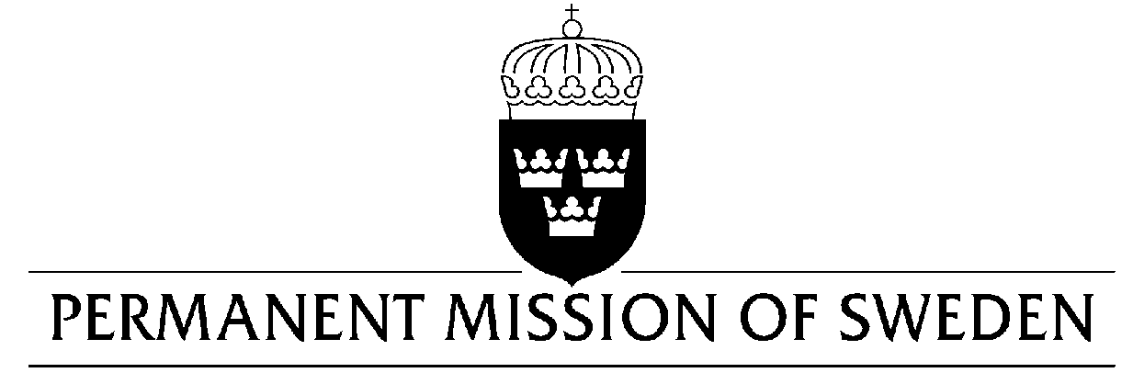
UN Human Rights Council

UPR 32nd session

Statement by Sweden in the interactive dialogue on Viet Nam
Geneva, 22 January 2019 (speaking time 1.00 min, speaker no. 58)

Mr. President,
Sweden acknowledges improvements on freedom of religion or belief, and the human rights of LGBTI-persons. However, continued efforts are needed. A worrying trend is shrinking space for civil society and an increased number of convictions of dissidents, human rights defenders, and bloggers, and lack of transparency regarding the number of death sentences. Sweden would like to make the following recommendations:

- To ensure that freedom of expression is protected online and offline by amending national security provisions in the Penal Code, and the Cybersecurity law and its implementing decree, so as to comply with article 19 of ICCPR and other commitments.

- To introduce a national moratorium on the death penalty, aiming at complete abolition. Until then, reduce the number of crimes subject to the death penalty, ensuring that it does not apply to offences other than the ”most serious” crimes, in accordance with ICCPR.

- To develop, enact and implement, in dialogue with business and civil society, an action plan to implement the UN Guiding Principles on Business and Human Rights.

Sweden wishes Viet Nam all success in the current review.

I thank you Mr. President.

