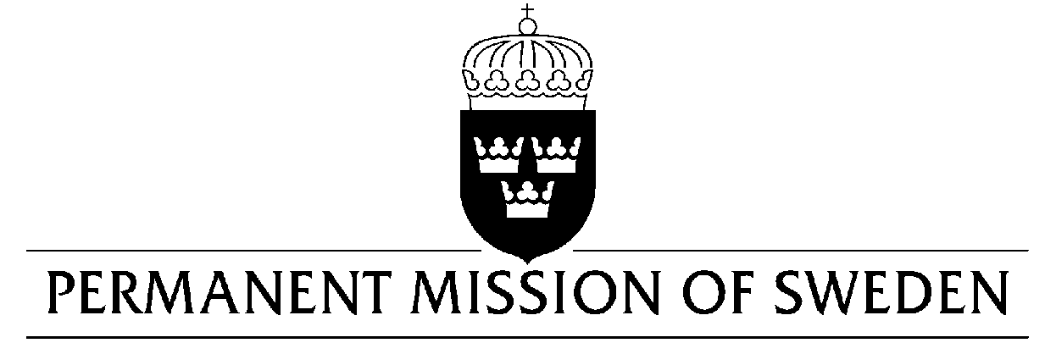
UN Human Rights Council

UPR 32nd session

Statement by Sweden in the interactive dialogue on Chile

Geneva, 22 January 2019 (speaking time 1.10 min, speaker no. 97)

Mr. President,

Sweden acknowledges the Chilean governments commitments to women’s and girls’ full enjoyment of human rights, as well as welcomes the strengthening of LGBTI-persons’ full enjoyment of human rights. However, challenges still persist in relation to the implementation of existing legislation, as well as social and economic exclusion for persons in marginalized and vulnerable situations, and would therefore like to make the following recommendations:

- To eliminate all barriers to the full implementation of the abortion law, including institutional conscientious objection.

- To decriminalize abortion in further cases, in particular when there is a risk to the physical or mental health of the pregnant woman, or pregnancy is a result of incest.

- To legalize same-sex marriage.

- To ensure that the implementation of the antiterrorism law is non-discriminatory, also as regards indigenous peoples.

Sweden wishes Chile all success in the current review.

I thank you Mr. President.

