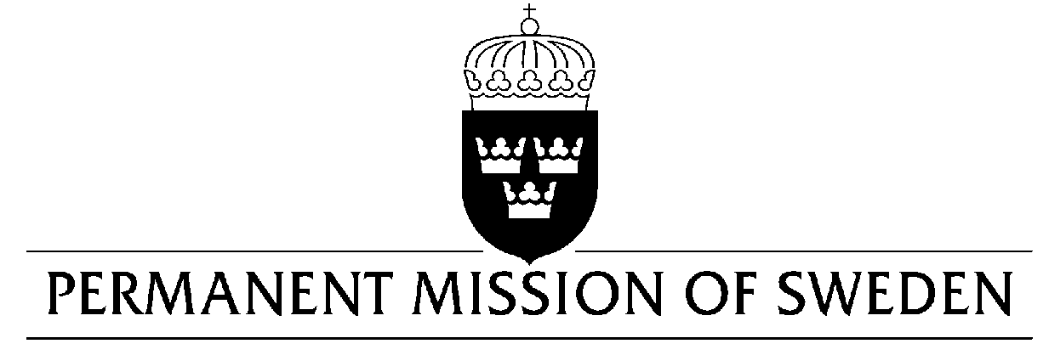
UN Human Rights Council

UPR 32nd session

Statement by Sweden in the interactive dialogue on Afghanistan

Delivered by Ambassador Mikael Anzén
Geneva, 21 January 2019 (speaking time 1.10 min, speaker no. 1)

Mr. President,

Despite the current conflict plaguing Afghanistan, the government has shown a commitment to protect human rights. Afghanistan has acceded to most of the core human rights treaties and has made progress adopting legislation to address gaps in regard to the protection of human rights. However, Sweden remains seriously concerned over the human rights situation in Afghanistan and would therefore like to make the following recommendations:

- To take effective measures to strictly enforce the national prohibition of torture and to ensure that no detained persons are subjected to unlawful treatment, that all allegations of such treatment are duly investigated by the proper criminal authorities and perpetrators held to account.

- To implement a moratorium on executions, aiming at complete abolition, and to commute the existing sentences of capital punishment to other forms of punishments.

- To integrate the National Action Plan for the Security Council resolution 1325 in national programs through the regular budget.

Sweden wishes Afghanistan all success in the current review.

I thank you Mr. President.

