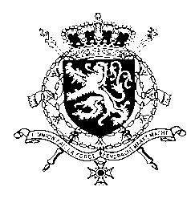
Représentation permanente de la Belgique auprès des Nations Unies et auprès des institutions spécialisées à Genève

UPR 32 – Eritrea
Belgian Intervention
Date: 28 January 2019

Mr President,

Belgium welcomes the delegation of Eritrea and wishes it every success in its third Universal Periodic Review.

We welcome Eritrea’s recent efforts towards a normalisation of its relation with Ethiopia, which we expect to have a positive impact on the broader region.

My country wishes Eritrea all the best as newly elected member of the Human Rights Council. Its membership of this Council should be an incentive to strengthen its engagement with international human rights bodies and procedures.

[My country is convinced that progress in the field of human rights should be pursued in several areas. We would hereby like to draw particular attention to the fragile situation of women and children.]

My country would like to formulate the following recommendations:

R1: to enhance its cooperation with the UN human rights mechanisms, including the special rapporteur for Eritrea.

R2: to put an end to the widespread use of sexual and gender-based violence against women and girls, in particular in detention facilities and in the context of national service and military training and bring those accused of such crimes to justice.

R3: to ensure that journalists and human rights defenders can exercise their right to freedom of expression, opinion and association and that appropriate follow up is given to cases of intimidation and harassment against them.

Thank you, Mr President.

