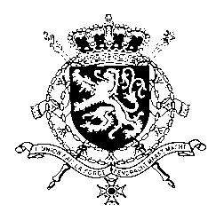
Représentation permanente de la Belgique auprès des Nations Unies et auprès des institutions spécialisées à Genève

WG UPR – Afghanistan
Belgian intervention
21st January 2019

Mr. President,

Belgium welcomes the delegation of Afghanistan and congratulates the government with the adoption of its first National Action Plan on Women, Peace and Security. However, Belgium is convinced that more progress can be achieved, especially regarding the realization of women’s rights.
Belgium therefore recommends the government of Afghanistan to:

R1. Ensure the effective implementation of the Law on the Elimination of Violence against Women, including by raising awareness and increasing knowledge of the law among the population, police forces and the judiciary.

R2. Set the legal age for girls to marry at 18 years and ensure that the law is effectively enforced, including by investigating and prosecuting cases of child marriage.

As a strong opponent of the death penalty, Belgium recommends Afghanistan at least to:

R3. Commute all existing death sentences for offenders who committed the crime for which they were sentenced while under the age of 18.

In testimony of our support of the role of Afghan women, Belgium announced in November 2018 a contribution of 2 million euros to the country office in Afghanistan of UN Women for their program to help with the implementation of the national action plan of Afghanistan on women, peace, and security related with UN Security Council Resolution 1325.

Thank you, Mr. President.

