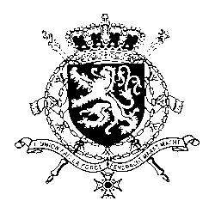
Représentation permanente de la Belgique auprès des Nations Unies et auprès des institutions spécialisées à Genève

WG UPR – Dominican Republic
Belgian intervention
30th January 2019

Mr. President,

Belgium welcomes the delegation of the Dominican Republic and wishes it every success in the exercise of its third Universal Periodic Review. We acknowledge the progress made by the Dominican Republic since its previous UPR. However, Belgium is convinced that further progress can still be achieved to increase the protection of human rights in line with the core international human rights treaties.

Therefore, we would like to formulate the following recommendations:

R1. Conduct thorough, independent and impartial investigations into femicide ensuring that the perpetrators are brought to justice and guaranteeing reparation for victims and their families for the harm suffered.

R2. Raise the minimum age of marriage to 18 years for both men and women and define child marriage as an offence in the Criminal Code.

R3. Reform the Criminal Code to decriminalize, as a first step, abortion in three cases: in the face of risks to the life of women, fetal malformations incompatible with extra uterine life, and pregnancies resulting from rape or incest.

Thank you, Mr. President.

