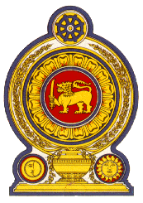

Statement by the Democratic Socialist Republic of Sri Lanka
32nd Session of the Universal Periodic Review
Review of the Islamic Republic of Afghanistan – 21 January 2019

Mr. President,

Sri Lanka welcomes the delegation of Afghanistan and appreciates the comprehensive presentation made today.

The enactment of laws on 'Prohibition of Torture' incorporating the provisions of the Convention against Torture and International Convention for the Suppression of the Financing of Terrorism in combating terrorism in all forms and manifestations is much appreciated.

We welcome the commitment of Afghanistan to remove the reservation on article 20 of the Convention against Torture and Other Cruel, Inhuman or Degrading Treatment or Punishment and its accession to the Optional Protocol to CAT without reservation.

We note with appreciation the continued efforts of the Government of Afghanistan to carry out the Afghan national plan for the implementation of Security Council resolution 1325 on women, peace and security.

My delegation recommends that Afghanistan:

- ensures access to immunization, particularly the polio vaccination, and uses its maximum available resources to ensure the availability and accessibility of quality health care for all,
- upholds the right to education ensuring the access to education for women and girls and ensures accountability for perpetrators of attacks on education institutions,
- adopts all necessary legal and regulatory measures to eliminate violence and discrimination against girls and women,

We wish Afghanistan success in its UPR engagement.
I thank you.

