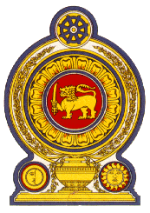

Statement by the Democratic Socialist Republic of Sri Lanka
32nd Session of the Universal Periodic Review
Review of New Zealand – 21January 2019

Mr. President,
Sri Lanka welcomes the delegation of New Zealand and appreciates the comprehensive presentation made today.
As reflected in the UPR Report, the Government of New Zealand has taken a series of steps for promotion and protection of human rights. As a progressive approach, it had even accommodated the views of secondary school students on human rights issues relevant to young people in preparing for the UPR, which we find extremely interesting and progressive for other countries including Sri Lanka to learn from.
We are pleased to note the efforts of the Government, including to increase diversity in New Zealand police, which we would like to learn about from the New Zealand experience.
On safeguarding the rights of the child, the measures aimed to introduce the child poverty reduction bill and the creation of the Ministry for Children are commendable.
We acknowledge the constructive approaches in education and health sectors particularly in relation to Maori and Pacific communities.
My delegation recommends that New Zealand:
- continue to focus on specific programmes and actions aimed at improving the health and education outcomes for Maori and Pacific communities,
- progress with the efforts in addressing disparities in mental health and improve the services for vulnerable groups,
- continue with affirmative action on children in vulnerable situation and child poverty reduction programmes and initiatives,
- consider ratification of the Convention on the Rights of Migrant Workers and Members of their Families.
We wish New Zealand success in its UPR engagement. Thank you.

