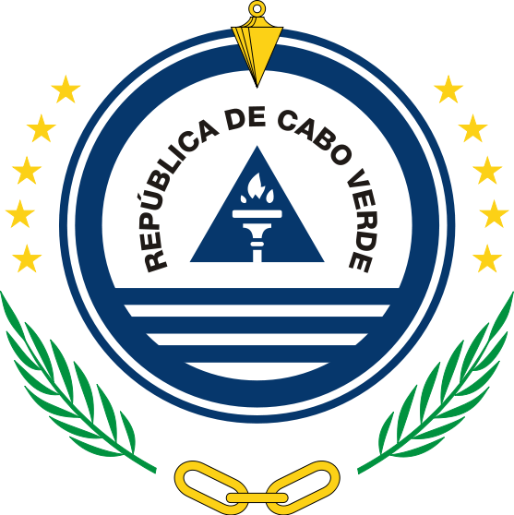

**Mission permanente de la République de Cabo Verde**

32nd Session of the UPR Working Group on the Universal Periodic Review

(21 Jan – 1 February 2019)

**Review of Uruguay**

**Intervention of Cabo Verde**

Maria de Jesus Veiga Miranda Ambassador / Permanent representative

Thank You, Mr Vice-President

The delegation of Cape Verde welcomes and thanks the Delegation of Uruguay for submitting its national report to the third cycle of the Universal Periodic Review.

We congratulate Uruguay on ratification of the Optional Protocol to the Convention on the Rights of the Child on Communications procedures.

We command the Government of Uruguay for the bold policies and plans for sustainable development, specially for the country renewable energy achievements.

We took note with satisfaction of the establishement of a national mechanism for reporting and follow-up on the implementation of the recommendations made during the second cycle of the UPR.

And respectfully recommend the Uruguay

1. To establish a human rights recommendations implementation plan aligned with the SDGs and integrating all accepted UPR recommendations ;
2. To integrate good practices of implementation of UPR recommendations into its national reviews on SDGs implementation
3. To create a mechanism facilitating the participation of uruguayans resident abroad in the electoral and other voting processes

We wish Uruguay plenty success in this review and in the implementation of accepted recommendations.

Thank you