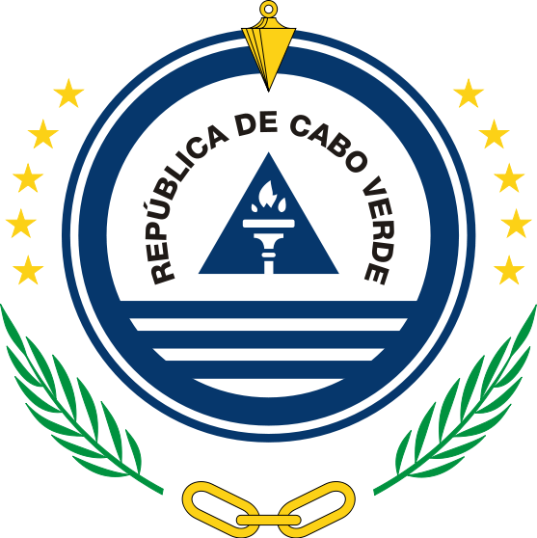

**Mission permanente de la République de Cabo Verde**

32nd Session of the UPR Working Group on the Universal Periodic Review

(21 Jan – 1 February)

**Review of Chile**

**Intervention of Cabo Verde**

Maria de Jesus Veiga Miranda Ambassador / Permanent representative

Thank You, Mme Vice-President,

The delegation of Cape Verde welcomes and thanks the Delegation of Chile for submitting its national report to the third cycle of the Universal Periodic Review.

We congratulate Chile on ratifying the International Labour Organization (ILO) Domestic Workers Convention and the Optional Protocol to the Convention on the Rights of the Child on Communications procedures.

We command the Government of Chile for submitting its midterm report on the implementation of the recommendations made during the second cycle of the UPR, held in 2014.

We take note with satisfaction of the establishement of the National Council for the implementation of the 2030 Agenda for Sustainable Development, which testifies the commitement of Chile to implement the SDGs.

And, in this regard, we recommend the following:

1. To promote an integrated approach to human rights and the SDGs, by encouraging direct collaboration of the national mechanism for reporting and follow up and the national coordination body for SDG’s/VNR reporting
2. To establish a human rights recommendations implementation plan, aligned with the SDGs and integrating all accepted UPR recommendations ;
3. To integrate good practices of implementation of UPR recommendations into its voluntary national reviews on SDGs implementation

We wish Chile plenty of success in this review and in the implementation of accepted recommendations.