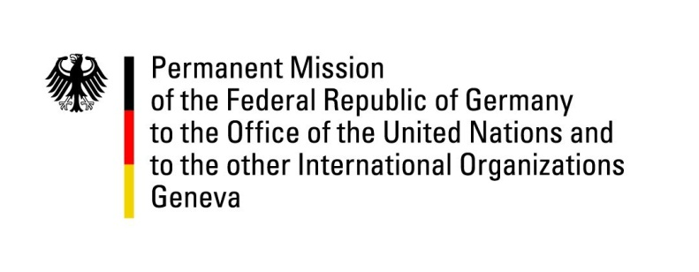

United Nations Human Rights Council

32nd Session of the UPR Working Group

Geneva, 30 January 2019

Recommendations and advance questions to
Cambodia

Mr. President,
We welcome the delegation of Cambodia. We commend improvements in the protection of the rights of children and increased efforts to fight trafficking.

Germany recommends:
- Cease excessive powers of the executive branch to influence the work of judges and prosecutors, by amending the Law on the Organization of the Courts, the Law on the Statue of Judges and Prosecutors and the Law on the Organization and Functioning of the Supreme Council of the Magistracy.
- In consultation with affected stakeholders and civil society, amend the Law on Political Parties (LPP), and the Law on Associations and Non-Governmental Organizations (LANGO), to bring them into line with international human rights obligations.
- Bring the Criminal Code into line with Article 19 of the International Covenant on Civil and Political Rights by repealing or amending articles on Insulting the King (437-bis), Defamation (305), Insult (307), Incitement (495&496), Unlawful Coercion of Judicial Authorities (522) and Discrediting Judicial Decisions (523).
- Ensure freedom of expression on the internet by revoking the inter-ministerial decree (No. 170 Br. K) on Publication Controls of Websites and Social Media Processing via the internet.
- Issue a standing invitation to the UN Special Procedures, and cooperate constructively with the Special Rapporteur on Human Rights in Cambodia and with the OHCHR.

Thank you, Mr. President.
GERMAN ADVANCE QUESTIONS TO CAMBODIA:
- How does the Kingdom of Cambodia plan to bring the Law on Associations and Non-governmental Organizations (LANGO) and the Law on Political Parties (LPP) in line with its human rights obligations, as documented in OHCHR’s human rights analysis of the two laws (for LANGO published on the 4th of August 2015, for LPP published on 28th March 2017)?
- In April 2018, the UN working Group on Arbitrary Detention came to the conclusion that the detention of Kem Sokha was arbitrary, a violation of his parliamentary immunity and that he should be released immediately and unconditionally. It concluded that the Cambodian government could not demonstrate that the prosecution on charge of treason was a “necessary, reasonable and proportionate response in protecting national security or public order.” In this light, how does Cambodia justify the continued restriction of his right to liberty by submitting him to highly restrictive and isolating house arrest?

