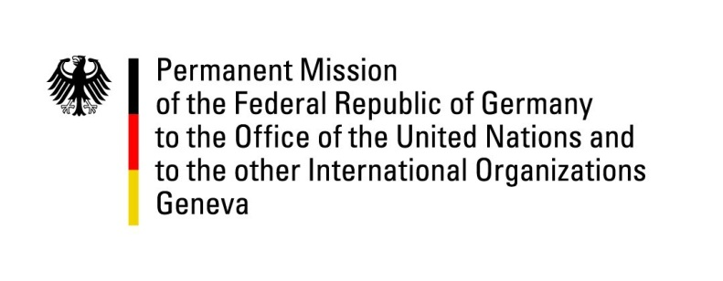

United Nations Human Rights Council

32nd Session of the UPR Working Group

Geneva 30. January 2019

German questions and recommendations to
The Dominican Republic

Mr. President,

Germany welcomes the delegation of the Dominican Republic and commends the progress made with regards to the reduction of statelessness, especially the adoption of the Naturalization Law in 2014 (Law 169-14) and the creation of a registration plan for foreign people. We welcome the efforts made in the fight against domestic violence and the improvements of women’s rights.

Germany is concerned about the remaining legal gaps causing statelessness, the situation of women, both with regard to their physical integrity and to their sexual and reproductive health and rights, the ongoing domestic violence against children and the critical conditions in Dominican prisons. Therefore, Germany would like to offer the following recommendations:

- Prevent and reduce statelessness, especially by implementing the Law 169-14, which provides for the registration of those applying for citizenship and recognizes the right of those born in the Dominican Republic before 26 January 2010 to obtain citizenship, including those in Group B of the Law whose births have so far not been registered in the Dominican Republic;
- Ensure that women are effectively protected from violence and are fully entitled to their sexual and reproductive health and rights, especially by approving the reform of the Criminal Code decriminalizing abortion in certain cases;
- Take effective measures to reduce violence against children, especially domestic violence, and ensure their access to education.
- Ensure that conditions of detention are in line with international human rights standards, including ending unlawful extensions of pre-trial detention.

Thank you, Mr. President

Advance Questions:

- What measures does the Government of the Dominican Republic take to improve the implementation of Law 169-14?

- What new measures does the Government of the Dominican Republic take to reduce domestic violence and child abuse?

- What measures does the Government of the Dominican Republic take to improve the situation in Dominican prisions?

