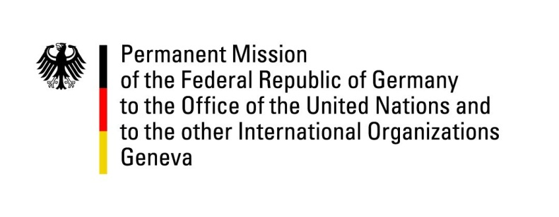

United Nations Human Rights Council

32nd Session of the UPR Working Group

Geneva, 28 January 2019

Recommendations and advance questions to
Eritrea

Thank you, Mr. President,

Germany welcomes the delegation of Eritrea. We commend Eritrea for the rapprochement and opening of the border to Ethiopia and the enabling of free exchange of persons and goods between both countries.
Germany remains concerned about the human rights situation, in particular of people in detention.
Germany recommends to:

- Implement the 1997 Constitution, alternatively step up the drafting of a new constitution in an inclusive and expeditious way, and hold free and fair elections with international monitoring without delay.

- Establish provisions for conscientious objections to military service and bring an end to indefinite, involuntary conscription for national service.

- Extend a standing invitation to the Special Rapporteur on the situation of human rights in Eritrea and to all other special procedures mandate holders, and cooperate fully with OHCHR.

- Review domestic legal provisions concerning religious groups and strengthen national legislation concerning freedom of religion and belief and ensure its free exercise.

- Release or bring before a court all persons detained without a charge and respect international standards in the treatment of detainees and provide unlimited access to the International Committee of the Red Cross to all detention facilities in the country.

Thank you, Mr. President.
Advance Questions
- Eritrea and Ethiopia signed a Joint Declaration of Peace and Friendship on 9 July 2018. Since then, the Government of the State of Eritrea has acknowledged that the threat against the security and sovereignty of Eritrea impeding the implementation of the Constitution of 1997 has been eliminated. When and how does the Government of Eritrea plan to implement the constitution and hold free and fair national elections? Alternatively, how will the Government conclude the process of drafting a new constitution, as mentioned in Eritrea’s mid-term report, in an inclusive and expeditious way?

- When does the Government of Eritrea envisage ending the practice of indefinite conscription for national service, now that the threat to national security and sovereignty has been eliminated?

