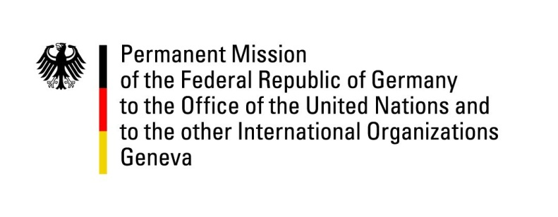

United Nations Human Rights Council

32nd Session of the UPR Working Group

Geneva, 28 January 2019

German questions and recommendations to
Slovakia

Thank you, Mr. President.

Germany warmly welcomes the delegation of Slovakia to the UPR. We praise Slovakia for its constructive engagement with the mechanisms of the Council and appreciate the efforts undertaken to implement the recommendations of previous UPR-cycles.

We commend the progress made with regard to the situation of national minorities and ethnic groups in Slovakia. We acknowledge the increasing participation of Roma in national, regional and local elections, and welcome the explicit recognition of crimes against Roma by the Government of Slovakia. We further commend the amendment of the Schools Act and promoting gender equality.

At the same time, we are concerned by some elements of the country’s legislation and practice, including the ongoing discrimination against Roma and the persistent hate speech in the media and on the internet, in particular against ethnic minorities, Muslims and non-citizens.

Germany recommends:

- Take further steps to protect and integrate Roma, inter alia by ensuring their equal access to housing, ending segregation of Roma children in schools and avoiding the discrimination of Roma in the labor market. Prosecute the excessive use of force by law enforcement officials against Roma.
- Take effective measures to guarantee the safety of journalists, and prosecute all attacks against journalists.
- Reinitiate the ratification process of the Istanbul Convention and take further steps to prevent violence against women as well as to promote gender equality.
- Adopt a National Action Plan to implement the United Nations Guiding Principles on Business and Human Rights.

Thank you, Mr. President.

Advance Questions:

- What measures has the Government of Slovakia taken in order to ensure the legitimate needs of LGBTI-people?
- How do you plan to establish a coherent approach for the integration of Roma, as discrimination is still persistent despite the manifold efforts by national and local governments as well as civil society? What are the next steps the Government is planning to push forward the integration of Roma? What are the government’s plans for strengthening acceptance of Roma in Slovak society and to tackle populist anti-Roma campaigns and sentiment?

