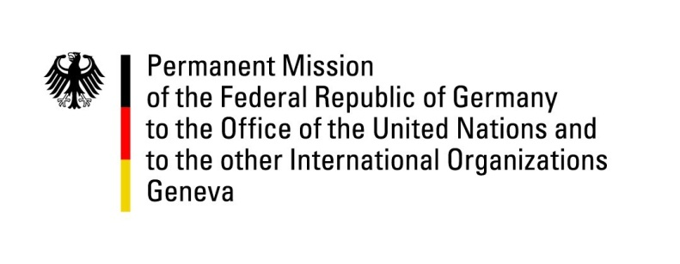

United Nations Human Rights Council

32nd Session of the UPR Working Group

Geneva, 25 January 2019

Recommendations and advance questions to
Comoros

Mr. President,

Germany welcomes the delegation of the Comoros to the UPR and commends the Comoros for ratifying the Convention on the Rights of Persons with Disabilities and the permission for ICRC and the National Human Rights Commission to access detention facilities.

However, Germany remains concerned about the human rights situation in the Comoros, in particular concerning the rights of women and the poor conditions in detention facilities.

Therefore, Germany offers the following recommendations:

- Amend national laws to effectively combat violence and discrimination against women.
- Ensure that victims of violence, particularly sexual and domestic violence, have access to justice and establish special facilities to provide medical, psychological, legal and financial support to them.
- Improve prison conditions inter alia by ensuring basic living conditions, i.e. food, medical support, access to drinking water and sanitation and by taking measures against over-crowding of prisons. Furthermore ensure that the maximum period of four months for pre-trial detention prescribed by law is not exceeded and that juveniles and adults are accommodated in separate detention facilities.
- Ratify the Second Optional Protocol of the International Covenant of Civil and Political Rights.

Thank you, Mr. President.

