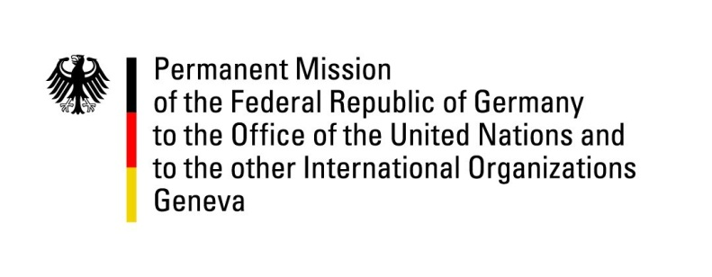

United Nations Human Rights Council

32nd Session of the UPR Working Group

Geneva 24. January 2019

German questions and recommendations to
FYR Macedonia

Thank you, Mr. President.

Germany welcomes the delegation of the FYR Macedonia to the third cycle of the UPR.
We welcome the efforts in regards to the rights of LGBTI persons in the FYR Macedonia and the Government’s demonstration of support to the LGBTI community. We further acknowledge the recent improvement of the climate for media freedom and freedom of expression, with more open political debate and critical media reporting, as well as the decrease in pressure on journalists.

However, Germany remains concerned by some elements of the country’s legislation and practice, in particular with regard to the independence of the media and the press, conditions of detention in prisons as well as the situation of living conditions of persons with disabilities.

Germany recommends:

- Continue to promote an enabling environment for freedom of expression and ensure that journalists and writers can work freely and without fear of retribution for expressing critical opinions and ensure the independence and diversity of media;
- Take effective measures to bring conditions of detention in line with international standards, notably with regard to the overcrowding of prisons and ensuring appropriate follow-up of all cases of alleged ill-treatment;
- Improve the living conditions of people in closed institutions and ensure their full health care;
- Introduce adequate measures to improve living conditions of persons with disabilities and step up efforts to ensure their full inclusion.

Thank you, Mr. President.

