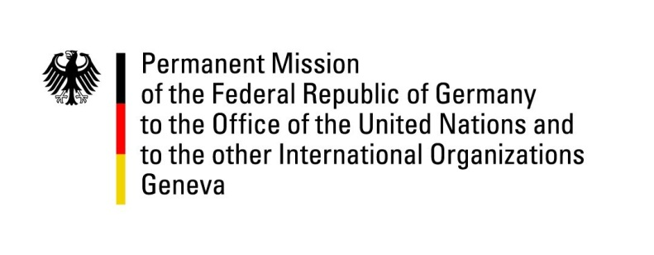

United Nations Human Rights Council

32nd Session of the UPR Working Group

Geneva, 24 January 2019

Recommendations and advance questions to
Vanuatu

Mr. President,
Germany welcomes the delegation of Vanuatu.
We commend improvements in the protection of the rights of children, in particular regarding free access to education.

Germany recommends:
- Expand measures to address violence, including sexual violence, especially against women and children, by enforcing the Convention on the Elimination of All Forms of Discrimination Against Women and the Convention on the Rights of the Child and implementing their human rights obligations into domestic legislation.
- Enhance the rights of LGBTI people by protecting them effectively from violence and discrimination.
- Enhance the capacity of the judiciary, especially with regard to the backlog of court cases and the staffing of the Public Prosecutor’s and the Public Solicitor’s Offices.

Thank you, Mr. President.
GERMAN ADVANCE QUESTIONS TO VANUATU:
- When will a fully-fledged National Human Rights Institution, with a mandate for oversight and in accordance with all Paris principles be put in place?
- How do you plan to deal with the backlog of court cases? Are there any plans to guarantee access to justice for the most vulnerable people?
- Are there plans to increase female participation in political processes at the area council, municipal and parliamentary levels?
- How do you plan to expand measures to address violence including sexual violence against women and children? How do you plan to enforce the provisions of CEDAW and CRC, which Vanuatu has ratified?
- How do you plan to ensure the rights of LGBTI people?

