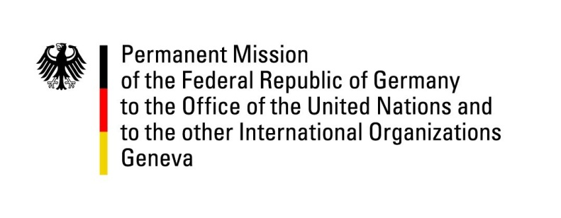

United Nations Human Rights Council

32nd Session of the UPR Working Group

Geneva, 23 January 2019

Recommendations and advance questions to
Yemen

Thank you, Mr. President,

Germany welcomes the delegation of Yemen. Germany recognizes the Government of Yemen’s constructive engagement in the negotiation process to find a political solution to the crisis. We remain very concerned about the humanitarian crisis and attacks on civilians.
Germany recommends:
- Allow unimpeded humanitarian access to Yemen, including through commercial aviation and also at Sana’a airport, and allow free movement for persons seeking medical care abroad;
- put pressure to halt airstrikes in highly populated residential areas and agree on safe zones that should not be targeted by airstrikes;
- ensure that all armed groups immediately cease recruiting child soldiers, release from duty all children who are under the age of 18, and ensure they have access to rehabilitation programs;
- ban child marriage and set the minimum age of marriage to 18 years and amend discriminatory domestic laws against women, especially with regard to male guardianship and control over women, and bring them in line with CEDAW;
- immediately end unlawful detention and release the names of all persons in custody.
- ensure that the Group of Eminent Experts has unrestricted access to areas controlled by the Government.

Thank you, Mr. President.

