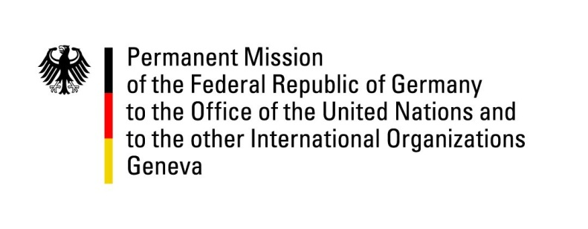

United Nations Human Rights Council

32nd Session of the UPR Working Group

Geneva, 23 January 2019

German recommendations and advance questions to

Uruguay

Mr. President,
Germany welcomes Uruguay to the UPR. We commend the Government of Uruguay for making significant efforts to integrate human rights into public policy by adopting laws that aim to tackle discrimination, enhance the rights of women (“Ley integral”) and LGBTI, especially Transgender (“Ley Trans”), and to improve the detention situation in prisons (“Criminal Procedure Code”). Nevertheless, Germany remains concerned about a number of human rights violations that continue to occur.
Germany recommends to:
- Strengthen efforts to reduce overcrowding in prisons by improving detention conditions and by reducing imprisonment of juveniles, and the long duration of pre-trial detention;
- Ensure the effective implementation and funding of measures contained in the Act on Gender-Based Violence against Women in order to reduce the persistently high rates of gender-based killings of women and bring those responsible to justice;
- continue implementing adequate measures in the fight against trafficking in women and girls for the purpose of sexual exploitation.
Thank you, Mr. President.

Advance Questions:
• Given the overcrowding of prisons, what is Uruguay doing to prevent the constantly high level of violence in prisons and to improve detention conditions?
• What measures is Uruguay taking to ensure the rehabilitation of juvenile delinquents?
• How will it be ensured that under the new Criminal Procedure Code procedures are sped up and pre-trial detention shortened?
• What measures is Uruguay taking to protect women from repeat offenders who are not in detention?
• Which measures have been taken in the fight against trafficking in women and girls for the purpose of sexual exploitation?

