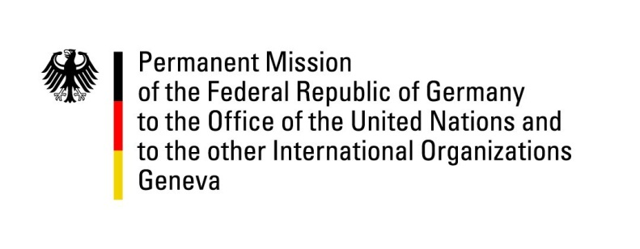

United Nations Human Rights Council

32nd Session of the UPR Working Group

Geneva, 22 January 2019

German recommendations to

Chile

Mr. President,
Germany welcomes Chile to the UPR. We commend you for the important progress since the 28th session of the UPR, particularly for the decriminalisation of abortion, as well as the establishment of the State Secretariat for Human Rights in the Ministry of Justice, the creation of the Ministry of Women and Gender Equality, a Children’s Rights Ombudsman and an Undersecretary for Children.
Germany remains concerned about reports about abuse and sexual exploitation of children in the National Children’s Service as well as about water contaminations through mining in northern Chile.
Germany recommends to:
- Establish an independent commission to investigate reports about abuse of children in SENAME, hold perpetrators accountable and improve the supervision of SENAME,
- Recognise the rights of indigenous peoples in the national constitution and ensure the participation of indigenous communities in decision-making processes that affect them,
- Eliminate remaining barriers to women’s access to safe and legal abortion.
- Improve nationwide access to water treatment plants and strengthen the relevant regulatory authorities.

Thank you, Mr. President.

Advance Questions:
- Which actions does Chile take to prevent child abuse, especially as reported within the Servicio Nacional de Menores, SENAME?
- What measures are taken to implement the ‘plan Araucania’ to ensure the constitutional protection of indigenous peoples’ rights? How are indigenous peoples’ territorial claims handled and how does the government receive criticism of human rights defenders on this subject matter?
- How does Chile strengthen alternative measures to detention for minor offences? What measures are taken to improve the situation for female offenders with children and young offenders?
- What action is Chile taking to address the high consumption of water in the industrial sector and the resulting water pollution? What actions does Chile take to ensure adequate wastewater treatment?
- Which measures exist to enhance gender equality in the workplace? Does Chile consider strengthening women’s social security rights?

