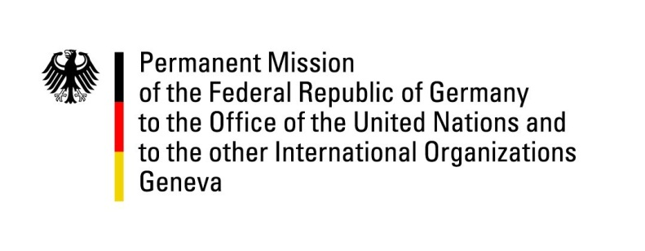

United Nations Human Rights Council

32nd Session of the UPR Working Group

Geneva, 21 January 2019

Recommendations and advance questions to
Afghanistan

Mr. President,
Germany welcomes the delegation of Afghanistan.
We commend Afghanistan for having ratified the Optional Protocol to the Convention against Torture in April 2018.

Germany recommends:
- Work steadily towards the establishment of a fair and independent judiciary system that is equipped with adequate resources.
- Promptly and thoroughly investigate allegations of torture of detainees, enforced disappearances, and summary executions, and prosecute those responsible.
- Enforce the existing legal prohibitions on the use of coerced confessions in judicial proceedings and take appropriate disciplinary action against prosecutors and judges who permit the use of such information.
- Take energetic measures to strengthen children rights, by promptly and thoroughly investigating all allegations of forced marriage, the practice of “bacha bazi”, or any other form of sexual exploitation of children, and appropriately prosecuting all those found responsible.

Thank you, Mr. President.

