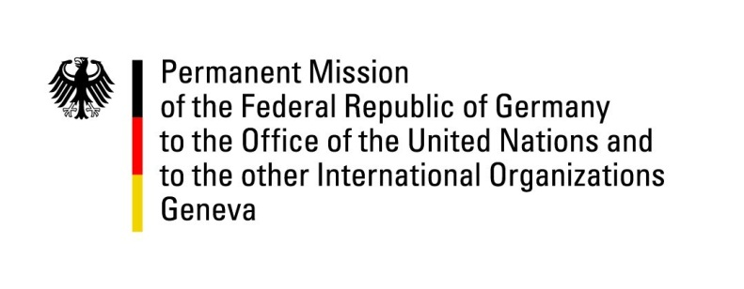

United Nations Human Rights Council

32nd Session of the UPR Working Group

Geneva, 21 January 2019

Recommendations and advance questions to
New Zealand

Mr. Vice-President,
Germany welcomes the delegation of New Zealand to the UPR and thanks for the report. We commend New Zealand for an exemplary track record on human rights.
We welcome the efforts to improve the human rights situation of marginalized groups, and in particular the intensified efforts made on reducing child poverty.

Germany recommends:
- Strengthen the human rights obligations of the Bill of Rights Act of 1990 by defining them as supreme law;
- Ensure that asylum-seekers are only detained in strict accordance with New Zealand’s international human rights obligations;
- Ensure that asylum-seekers have the right to a regular review of their detention status and have adequate access to lawyers, their families, health providers and support groups.
Thank you, Mr. Vice-President.
GERMAN ADVANCE QUESTIONS TO NEW ZEALAND:
- Does New Zealand consider the suggestion for a "Constitution for Aotearoa New Zealand" made by Geoffrey Palmer and Andrew Butler, which proposes to grant the Supreme Court the authority to review laws and revoke them if they are not in accordance with human rights obligations?
- Does New Zealand consider a review of the Terrorism Suppression Act in order to extend judicial overview?
- Which measures does New Zealand plan to reduce the socioeconomic differences between the overall society and Māoris and Pacific Islanders?

