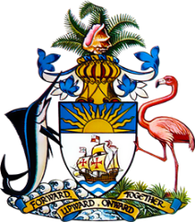

Statement by Ms. Sasha Dixon, Second Secretary
Permanent Mission of The Bahamas to the United Nations Office and Other International Organizations in Geneva
at the 32nd Session of the Universal Periodic Review Working Group
Presentation of National Report by the Government of Slovakia
28 January, 2019

Thank you [Mr./Madame] [Vice] President.
The Bahamas extends a warm welcome to the delegation of Slovakia.
We congratulate Slovakia for its ongoing efforts in the promotion and protection of human rights and acknowledge a number of important steps taken, including the approval of the National Strategy for the Protection of Children from Violence and the establishment of the National Coordination Centre for Resolving the Issues of Violence Against Children.
We also commend Slovakia on the establishment of the Office of the Commissioner for Children and the Office of the Commissioner for Persons with Disabilities.
We further welcome the approval of the Concept for the Fight against Extremism (2015 -2019), the Action Plan for Preventing and Eliminating Racism, Xenophobia and Antisemitism (2016- 2018) and the Action Plan for Preventing all Forms of Discrimination (2016- 2019).
With a view to encouraging further advancement, The Bahamas respectfully recommends that Slovakia:
- ensures the independence of the institution of the Commissioner for Children so as to guarantee full compliance with the Paris Principles;
- improves the functioning of the judicial system by implementing a ‘Swift Justice’ programme and an automated case management system to track the progress of cases so as to reduce the current backlog and
- implements legislation aimed at countering trafficking and allocating sufficient resources and funds to its anti-trafficking efforts.
I thank you.

