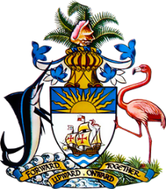

Statement by Mr. Frank Davis, Chargé d’Affaires, a.i.,
Permanent Mission of The Bahamas to the United Nations Office and Other International Organizations in Geneva
at the 32nd Session of the Universal Periodic Review Working Group
Presentation of National Report by the Government of Uruguay
23 January, 2019

Thank you [Mr./Madame] [Vice] President.
The Bahamas extends a warm welcome to the delegation of Uruguay.
Uruguay is to be commended for its clear commitment to the promotion and protection of human rights at the national level, including the numerous voluntary commitments undertaken in the context of this UPR process.

We recognize the passage of a number of key pieces of legislation such as legislation criminalizing discrimination, an Act on gender-based violence against women and an Act to combat trafficking and exploitation. Efforts to incorporate a gender perspective in policies on family farming to assist rural women, the implementation of the ‘right to equality and non-discrimination for persons with disabilities’ project as well as progress achieved in the reduction of carbon emissions are indeed welcome developments.

With a view to encouraging further improvements at the national level, The Bahamas respectfully recommends that Uruguay:

- fully implements the National Plan on Racial Equality and African Descent in order to address structural inequalities;
- takes concrete steps to accelerate progress in reaching the quota of posts in public bodies, including decision-making roles, to be allocated to people of African Descent and
- fully implements the agreed National Plan on Trafficking in Persons (TIP) and continues to conduct public awareness campaigns to combat TIP as well as to provide necessary TIP training to relevant officials.

We wish Uruguay every success in this UPR process.

I thank you.

