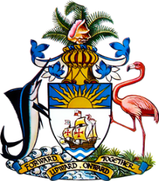

Statement by Mr. Frank Davis, Chargé d’Affaires, a.i.,
Permanent Mission of The Bahamas to the United Nations Office and Other International Organizations in Geneva
at the 32nd Session of the Universal Periodic Review Working Group
Presentation of National Report by the Government of Chile
22 January, 2019

Thank you, Mr. [Vice] President.
The Bahamas extends a warm welcome to the delegation of Chile.
We congratulate Chile for its ongoing efforts in the field of human rights. Particularly noteworthy is Chile’s leadership in promoting ratification of the Convention Against Torture (CAT) through the Convention against Torture Initiative (CTI). Moreover, welcome developments include Chile’s establishment of a dedicated human rights arm of government – the office of the Undersecretary for human rights. Equally commendable are policies and programmes such as the Health and indigenous peoples policy; financing initiatives for sustainable indigenous production; implementation of a National Gender Equality plan for 2018-2030, a National Plan of Action for Children and Adolescents (2018-2025) and a National Human Rights Plan (2018-2021).

With a view to encouraging further improvements, The Bahamas respectfully recommends that Chile:

- implements necessary reforms to ensure full access to inclusive, quality education for all, regardless of socioeconomic status;
- takes steps to ensure availability of safe drinking water and sanitation, particularly for those in rural areas and
- conducts sustained public information and awareness campaigns, targeting youth, to combat the rise in HIV infections as well as stigma and discrimination.

We wish Chile every success in this UPR process.

I thank you.

