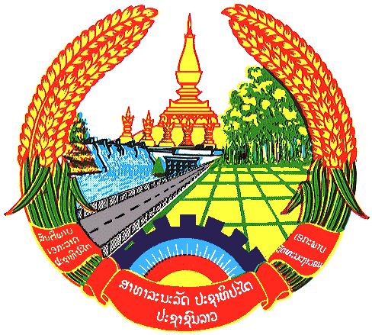

Statement by the delegation of the Lao PDR
At the 32th Session of UPR Working Group
Geneva, Switzerland

Review of Dominican Republic: 30 January 2019

Mr. President,
The Lao delegation would like to warmly welcome the delegation of the Dominican Republic and congratulate for its comprehensive National Report on Human Rights.

The Lao PDR commends the Government of the Dominican Republic for the progress made in its efforts to promote and protect the rights of women and girls as well as to eliminate poverty in the country through the “progressing with Solidarity” programme.

Taking this opportunity, the Lao PDR would like to recommend as follows:

- Continue its efforts to further strengthen the social protection, especially the protection of the rights of women and girls through its national policies and programmes;
- Continue its programmes on poverty elimination and social development; and
- Continue to provide supports to educational institutions to ensure that children and teenagers can access to state-sector educational institutions.

We wish Dominican Republic a successful UPR.

I thank you, Mr. President.

