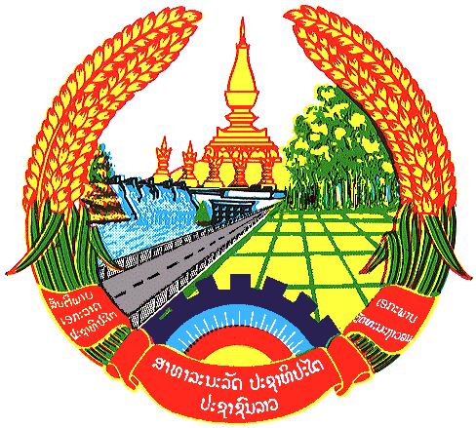

Statement by the delegation of the Lao PDR
At the 32th Session of UPR Working Group of Human Right Council
Geneva, Switzerland

Review of Uruguay: 23rd of January 2019

Mr. President,
The Lao delegation would like to welcome the delegation of Uruguay to the UPR session and would like to thank for its comprehensive National Report on human rights.

We welcome the progress made in efforts of the Government of Uruguay for in promoting and protecting human rights for its citizen, especially the rights of children and adolescents through its various national policies and programs.

On this occasion, we would like to recommend Uruguay the followings:

- First, continue its efforts to adopt the National Plan for the Care of Children and Adolescents to ensure that they are given proper care and social-economic aid; and
- Second, continue the scholarship and support systems for students to ensure they continue to be in formal education system as well as to prevent them from dropping out of school.

We wish Uruguay every success in its third cycle of UPR.

I thank you, Mr. President.

