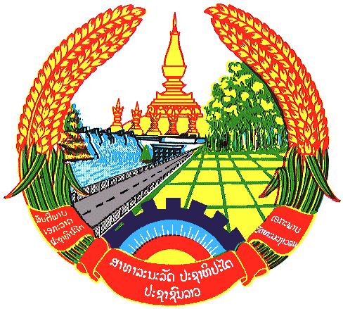

Statement by Mr. Sitsangkhom SISAKETH
Counsellor and Deputy Permanent Representative
Permanent Mission of the Lao PDR
At the 32th Session of UPR Working Group
Geneva, Switzerland

Review of New Zealand: 21 January 2019

Mr. President,
The Lao delegation welcomes the delegation of New Zealand to the 32nd session of UPR Working Group and would like to thanks them for the presentation of its National Report on human rights.

The Lao delegation would like to commend New Zealand for its promoting and protecting human rights at home and oversea, in particular the effort of promoting economic, social and cultural rights, which are vital for the development of diverse societies in New Zealand.

In this connection, my delegation wishes to recommend the Government of New Zealand to continue its effort to address the ongoing challenges, including the impact of environment through the implementation of Environmental Health Action Plan.

We wish New Zealand all the success in its UPR.

I thank you, Mr. President.

