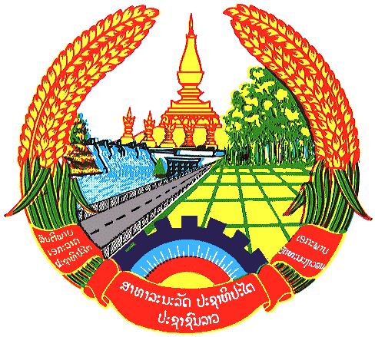

Statement by Mr. Sitsangkhom SISAKETH
Counsellor and Deputy Permanent Representative
Permanent Mission of the Lao PDR
At the 32th Session of UPR Working Group
Geneva, Switzerland

Review of Cyprus: 29 January 2019

Mr. President,
The Lao delegation warmly welcomes the delegation of Cyprus and congratulates for its comprehensive national report, demonstrating human rights development in the country.

The Lao PDR would like to commend Cyprus on the good progress in implementing the recommendations made in the previous UPR, including the promotion of gender equality and the rights of women and children through its various legislative initiatives, measures and programmes.

In this respect, Laos wishes to recommend Cyprus as follows:

- Continue to implement the national policies and programmes aimed at further promoting gender equality as well as the rights of women and children; and
- Continue its efforts for further advancement of raising awareness and education on human rights.

We wish Cyprus a successful UPR.

I thank you, Mr. President.

