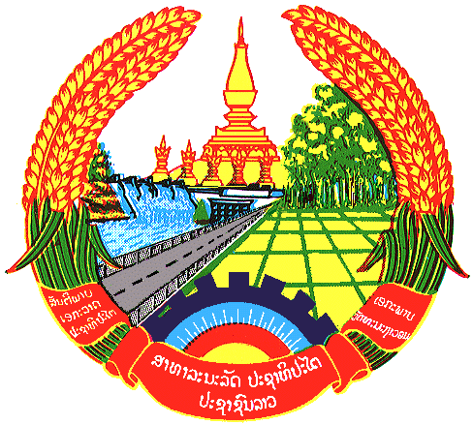

Statement by H.E. Kham-Inh KHITCHADETH, Ambassador and Permanent Representative of the Lao PDR
At the 32th Session of UPR Working Group
Geneva, 21 Jan - 01 Feb 2019

Review of Cambodia: 30 January 2019

Mr. President,
Lao People’s Democratic Republic warmly welcomes the high level delegation of Cambodia to the 32nd Session of UPR Working Group and commends for its comprehensive national report on human rights.

Laos sincerely commends the Government of Cambodia for the achievements made in its efforts to eliminate discrimination against women and to promote gender equality through the development and the implementation of legal frameworks, policies, action plans and programmes. We also commend Cambodia for the remarkable progress made in the education sector.

In this connection, Laos has three recommendations:

- First, continue to upgrade quality and efficiency of education services at all general vocational and skill training schools;

- Second, continue to implement gender equality policy by mainstreaming gender in all sectors and programs; and

- Third, strengthen roles and status of women and promote and protect child rights and disability persons in the society.

We wish Cambodia every success in its UPR.

I thank you, Mr. President.

