Full version

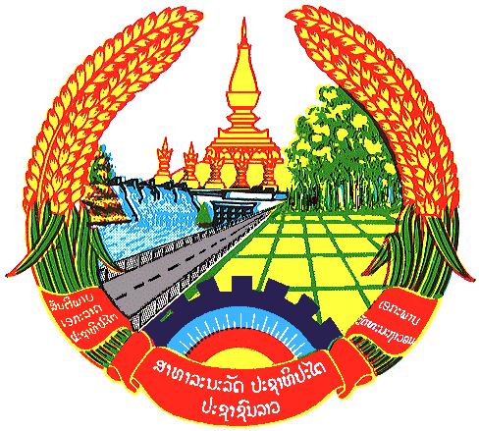

Statement by H.E. Kham-Inh KHITCHADETH, Ambassador and Permanent Representative of the Lao PDR
At the 32th Session of UPR Working Group
Geneva, 21 Jan. - 01 Feb. 2019

Review of Viet Nam: 22 January 2019, at 14:30 - 18:00

Mr. President,
Lao delegation wishes to warmly welcome the high level delegation of Viet Nam led by H.E. Mr. LE Hoai Trung, Vice Minister for Foreign Affairs to the 32nd Session of UPR Working Group and appreciates its national report that is very comprehensive and informative, and also reflects the development of promotion and protection of human rights in Viet Nam.

Laos sincerely congratulates Viet Nam for the encouraging achievements made in its efforts in promotion and protection of human rights through mainstreaming human rights in Viet Nam’s socio-economic development strategies and policies, as well as the implementation of the accepted recommendations in the previous cycles.

In this connection, Laos has three recommendations:

- First, take steps to preserve and promote a vibrant and diverse religious and belief life in Viet Nam;

- Second, guarantee the People’s Procuracy’s role in protecting human rights, in accordance with the new regulations of the 2015 Law on Administrative Procedure;

- Third, raise awareness among its people on the roles and responsibilities of the ASEAN Intergovernmental Commission on human rights (AICHR).

In this connection, we commend Viet Nam’s remarkable achievements made in socio-economic development and the implementation of the 2030 Agenda for sustainable development. I thank you, Mr. President.

