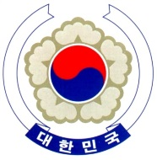

PERMANENT MISSION OF THE REPUBLIC OF KOREA
GENEVA

The 32nd Session of the UPR Working Group <Check against delivery>
Review of Cyprus
Geneva, 29 January 2019

Statement of the Republic of Korea

Thank you Mr. President.

The Republic of Korea would like to join others in welcoming the delegation of Cyprus to its third cycle of the UPR.

We commend the government’s strong commitment to implement recommendations from its second cycle despite financial and human resource constraints. Cyprus has ratified since 2014, five major international legal instruments in areas such as the rights of women, children, and persons with disabilities, and has made constant efforts to bring national legislation in line with such standards. In particular, the National Action Plan for Gender Equality 2018-2021 is an ambitious and comprehensive agenda that seeks to promote the rights of the most vulnerable groups of women.

Bearing in mind the progress made, today we have the honor to present the following recommendations.

- Keep up the efforts to investigate all cases of human trafficking and ensure that perpetrators are brought to justice.

- Strengthen the efforts to promote inter-religion dialogue and understanding.

We wish Cyprus a successful review. I thank you. /END/

