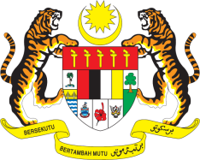

STATEMENT BY MALAYSIA
Review of Cambodia
32nd Session of the UPR Working Group
30 January 2019

Thank you Mr. President.

Malaysia warmly welcomes the delegation of the Kingdom of Cambodia to the 32nd Session of the UPR Working Group and congratulates them for the presentation of their national report.

- Economic development and growth are imperative to improve living conditions and promote livelihood of Cambodians. While Malaysia is pleased with efforts undertaken towards promoting socio-economic developments in the country, we believe that improvements could be further made. In this regard, we recommend Cambodia to continue implementing policies to promote economic growth and implement wide range programmes to alleviate poverty.

- Malaysia notes Cambodia´s progress in improving access to health care services. Under the Health Strategic Plan 2016-2020, everyone including those living in rural areas are able to obtain quality health-care services. We also note that the Government is continuing efforts to curb tuberculosis by providing free treatments. Malaysia recommends that these efforts to be sustained and relevant policies aimed at total eradication of tuberculosis to be fully implemented.

- As a fellow member of ASEAN, Malaysia appreciates Cambodia´s on-going policies and programmes aimed at improving human rights in the country and join the many friends of Cambodia in wishing it a successful review.

I thank you, Mr. President.

GENEVA
30 January 2019

