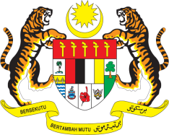

STATEMENT BY MALAYSIA
Review of Cyprus
32nd Session of the UPR Working Group
29 January 2019

Thank you Mr. President.

Malaysia welcomes the delegation of Cyprus and thanks them for the presentation of their national report.

- Malaysia appreciates the update by Cyprus in the promotion and protection of human rights since its second UPR. Malaysia commends the Government of Cyprus for progress made especially in socio-economic sectors.

- While there are advancements, prevailing challenges in the area of poverty reduction, healthcare and education could be better addressed by the Government in order to improve the living conditions of its people. In this regard, my delegation wishes to make the following three recommendations for the consideration of Cyprus:

  - One: Continue undertaking measures to eradicate poverty and allocate adequate resources to assist those living in poverty;

  - Two: Increase access in the health care sector for persons with disabilities to seek medical treatment; and

  - Three: Address discrimination and sexual harassment faced by girls in schools.

- Malaysia wishes Cyprus a successful review.

I thank you, Mr. President.

GENEVA
29 January 2019

