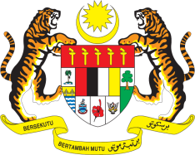

STATEMENT BY MALAYSIA
Review of Comoros
32nd Session of the UPR Working Group
25 January 2019

Mr. President.

Malaysia warmly welcomes the delegation of Comoros.

- Malaysia commends Comoros for the progress in the promotion and protection of human rights in its country as attested by the development of numerous national initiatives catered towards improving social and economic well-being of its citizens. We look forward to the effective implementation of these policies and programmes.

- Malaysia notes that the Government of Comoros has adopted a National Health Care Policy which among others seeks to increase access to health-care services. We take note of the existing challenges caused by lack of trained health-care personnel and health facilities. In this regard, Malaysia recommends to Comoros to ensure a long-term and sustainable funding is allocated for the health care sector to improve and guarantee wide coverage of health-care services for all.

- Malaysia is pleased with the increased rate in enrolment for children particular for girls and illiteracy rate has decreased among young people. These developments are indeed encouraging and should be sustained. Therefore, Malaysia recommends that Comoros continue its efforts to improve access to quality education, increase enrolment and promote retention of students in schools.

We wish Comoros a successful review.

I thank you, Mr. President.

25 January 2019
Geneva

