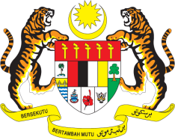

STATEMENT BY MALAYSIA
Review of Yemen
32nd Session of the UPR Working Group
23 January 2019

Thank you, Mr. President.

Malaysia welcomes the delegation of Yemen and thanks them for the presentation of their national report.

2. Malaysia recognises that Yemen is confronted with challenges, particularly in consolidating peace and stability as well as in tackling economic difficulties in the country. Yemen is also facing dire humanitarian situation adversely affecting its civilians, mostly children and women.

3. Despite these persisting challenges, Yemen has undertaken measures to continue promoting and protecting human rights in the country. Malaysia hopes that peace and security will soon be restored in Yemen. In the context of Yemen’s UPR, Malaysia would like to offer the following recommendations:

3.1. Intensify efforts to prevent children from unlawful recruitment and use by armed forces;

3.2. Continue efforts to provide psychosocial support and rehabilitation services to children affected by armed conflicts;

3.3. Undertake measures to curb gender-based and sexual violence; and

3.4. Promote women’s participation in decision making and peace process.

4. Malaysia wishes Yemen a successful UPR.

I thank you, Mr. President.

GENEVA
23 January 2019

