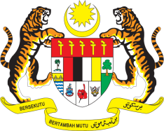

STATEMENT BY MALAYSIA
Review of Uruguay
32nd Session of the UPR Working Group
23 January 2019

Thank you, Mr. President.

Malaysia recognises the continued efforts of Uruguay to improve its national frameworks for the advancement of human rights in the country and welcomes progress in implementing recommendations from its second UPR. Malaysia is convinced that further steps could also be taken in the area of children, women and indigenous peoples’ rights.

2. In the spirit of constructive engagement, Malaysia recommends the following:

2.1. Allocate adequate budget to relevant national mechanisms on children’s affairs particularly to further advance inclusive education for children with disabilities;

2.2. Further protect women’s rights by providing more assistance to marginalised women including those with disabilities;

2.3. Continue taking effective measures to prevent sexual violence against women, ensure all cases of sexual violence are investigated, perpetrators are brought to justice and victims are provided with medical and psychosocial services;

2.4. Address the shortage of shelters for victims of domestic violence and ensure access to support system is widely available including in rural areas; and

2.5. Adopt robust measures to ensure full participation of indigenous people in public affairs as well as increase their presence in decision-making positions both in government and private sectors.

Malaysia wishes Uruguay a successful UPR.

I thank you, Mr. President.

GENEVA
23 January 2019

